Papers written by Australian Maths Software

SEMESTER ONE

MATHEMATICS SPECIALIST

UNIT 1

2015

SOLUTIONS

Section One
1. (a)
✓

(b)
✓
(c) 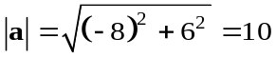 ✓
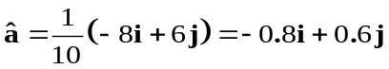 ✓
(d) The scalar projection of of a on b is -8. ✓✓
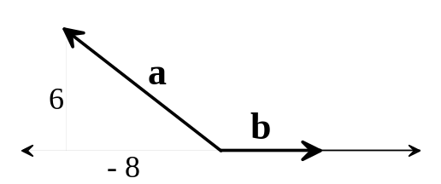

(e) 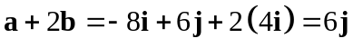 ✓
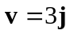 ✓
(8)

2. (a) The worst case is for the first seven people all to have birthdays on different
days of the week. ✓
✓
The minimum number of people that need to be selected is 8.
(b) Show that 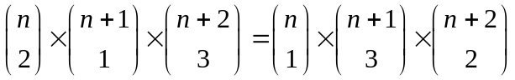
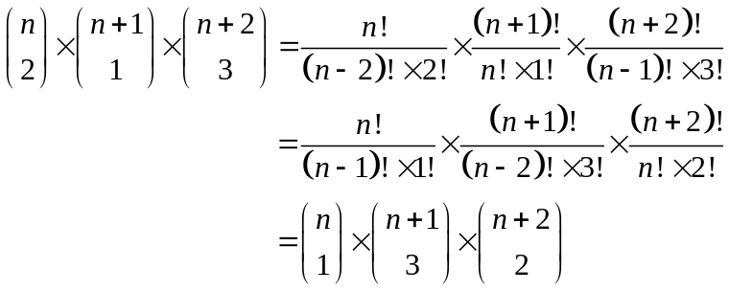
✓✓ -1/error

✓✓

✓

✓✓ -1/error

✓✓

✓

(6)
3. (a) Converse: I eat, therefore I am human.
✓ ✓
✓

✓✓

✓

(b) No, animals also eat and they are not human.
✓ ✓
✓

✓✓

✓

(c) Contrapositive: If you do not eat, then you are not human.
✓ ✓
✓

✓✓

✓

(d) Yes, the statement is valid.
✓

✓✓

✓

If you do not eat, you die. Humans need to eat. (8)
✓ ✓
✓

✓✓

✓

✓

✓✓

✓

4. (a) (i) A rhombus has diagonals that bisect at right angles, but it is not a square.
✓
(ii) Not valid for 
For example 
✓

(iii) It is possible to have an animal with big ears that is not an elephant.
✓ ✓
✓

✓✓

✓

eg Basset hound, a dessert lynx, a Californian leaf-nosed bat etc

(b) Four equal sides does not imply a square so 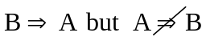 ✓ ✓

(c) For all real x, there exists  such that 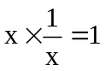for x not equal to 0.
✓✓✓ -1/error

✓✓

✓

(11)
5. Use a proof by contradiction to show that

“The sum of the angles in a triangle add to 180⁰ ”.

Assume that the angles of the triangle ABC do not add up to 180⁰.
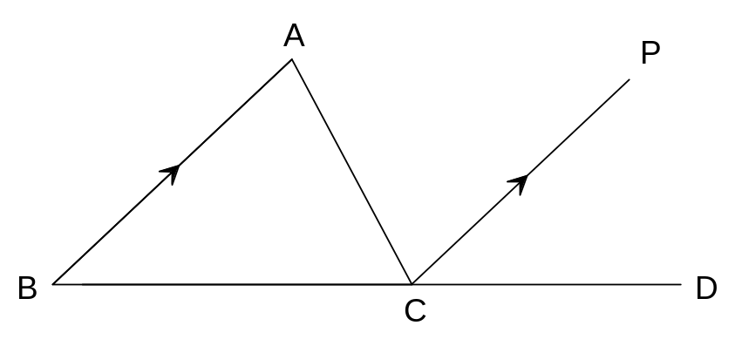

Extend BC to D.
Draw CP parallel to BA.
✓

✓✓

✓

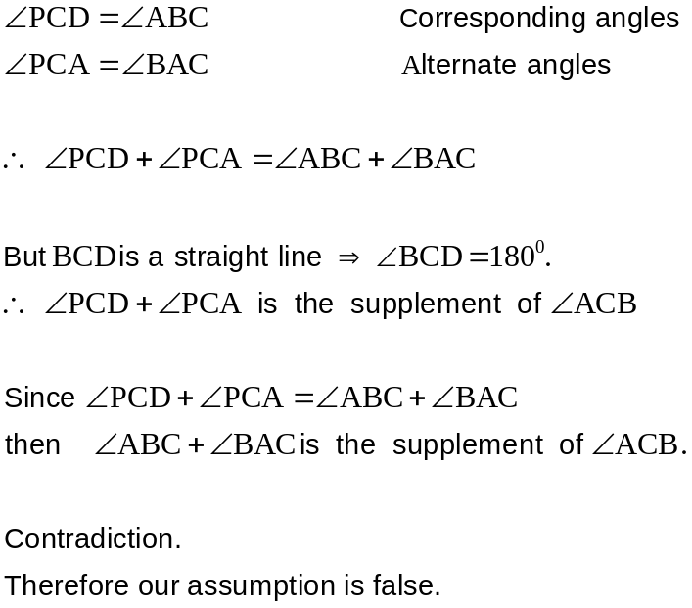
✓

✓✓

✓

✓

✓✓

✓

✓

✓✓

✓

✓

✓✓

✓

✓

✓✓

✓

the sum of the angles of the triangle ABC do add up to 180⁰.

Therefore “The sum of the angles in a triangle add to 180⁰ ”.

(6)

`
6. Prove that
"The sums of the squares of the lengths of the diagonals of a parallelogram is equal to the sum of the squares of the lengths of the sides.”
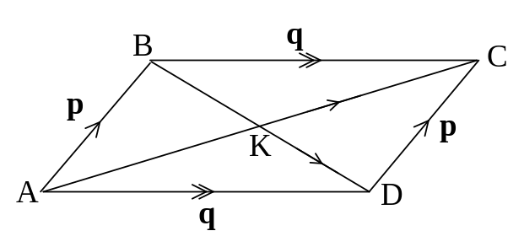
AB = DC = p and AD = BC = q
✓
AC = p + q BD = - p + q
✓
AC AC = | AC|×| AC|×cos(0º) = | AC|² = AC²
Similarly, BD BD = BD²

Therefore
✓
AC² + BD² = (p + q)² + (- p + q)²
✓
= pp + qp + pq + qq + pp - qp - pq + qq
= 2pp + 2qq
✓
= 2|p|² + 2|q|²
= 2AB² + 2AD² but AB = DC and AD = BC
✓
AC² + BD² = AB² + DC² + AD² + BC²

Therefore
"The sums of the squares of the lengths of the diagonals of a parallelogram is equal to the sum of the squares of the lengths of the sides.”
(6)
7. Use a vector proof to prove that
“If the midpoints of a quadrilateral are joined, the resulting quadrilateral is a
parallelogram.”

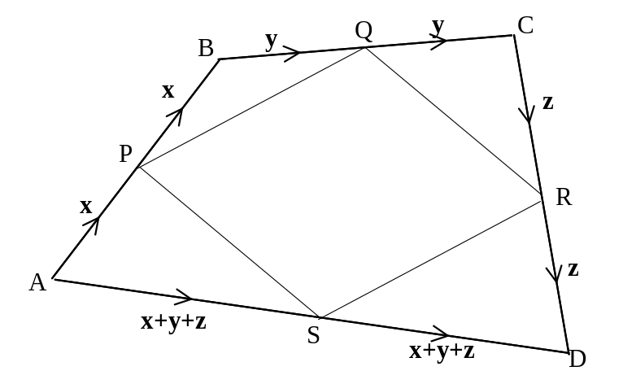
✓
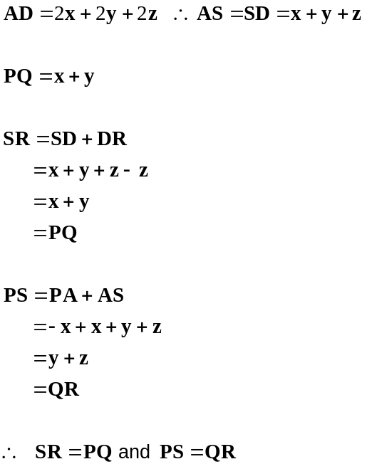
✓
✓
✓
✓
Two pairs of parallel and equal sides!
Therefore PQRS is a parallelogram.

Therefore
“If the midpoints of a quadrilateral are joined, the resulting quadrilateral is a
parallelogram.”

(5)
END OF SECTION ONE
Section Two
8. (a) 6 × 2! = 12 ✓✓

(b) 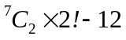 ✓
= 30 ✓
(4)

9. (a) 26² ×10³ = 676 000
✓ ✓
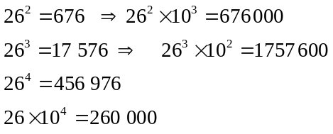
(b)

✓✓ working

Need one letter and 4 digits to obtain the least number of plates over
✓
200 000.

(c) (i) Worst case 4 + 2 + 3 = 9 ✓
So you need to select 10 fruit to ensure there is at least one of each type
of fruit. ✓

(ii) Either the two fruit are the same or they are different.
There are 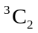 ways of selecting two different fruit. ✓
There are 3 ways of selecting two fruit that are the same. ✓
+ 3 = 6 ✓
(10)

10. (a) Given then
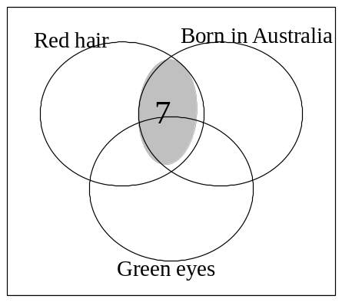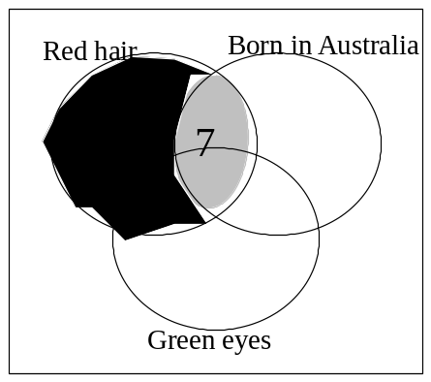
✓
✓
Therefore and it is known that green eyes only is 2%
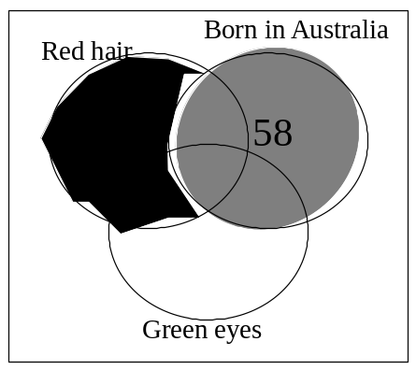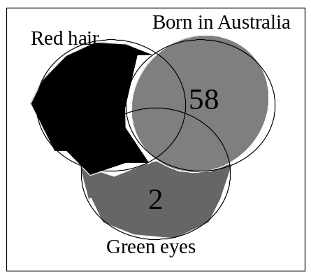
✓
✓
Therefore the percentage of the year 11 group that did not have red hair, were not born in Australia and did not have green eyes is 100 – 67 = 33%
✓
(b) 3% of the students had red hair but not green eyes and were not born in Australia.
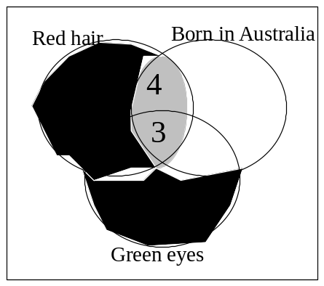 ✓

(6)

11. (a) | b | = 5
16 + x² = 25 ✓
x = ± 3 ✓
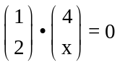 (b)
✓

4 + 2x = 0
✓

x = -2

(c) 
✓

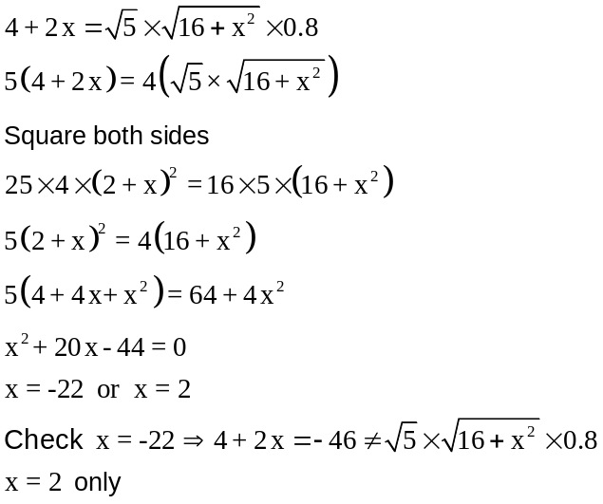
✓

✓

✓

✓

(9)
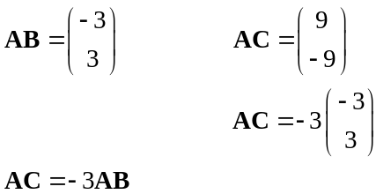12. (a)
✓✓

✓

Therefore AC is parallel to AB
✓

✓

A is a common point.
Therefore A, B and C are collinear.

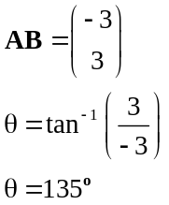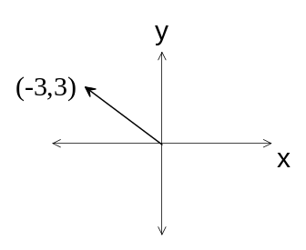(b)
✓

✓

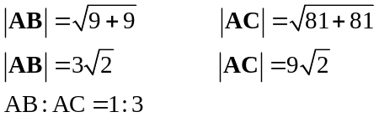 (c)
✓

✓

✓

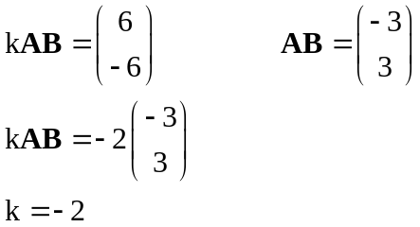 (d)
✓

✓

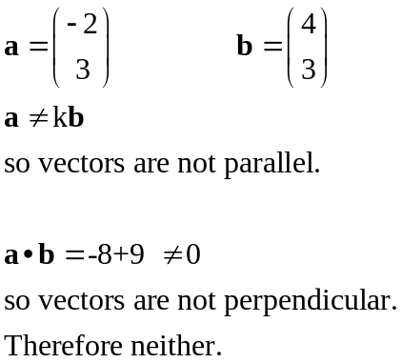
(e)
✓

✓

✓

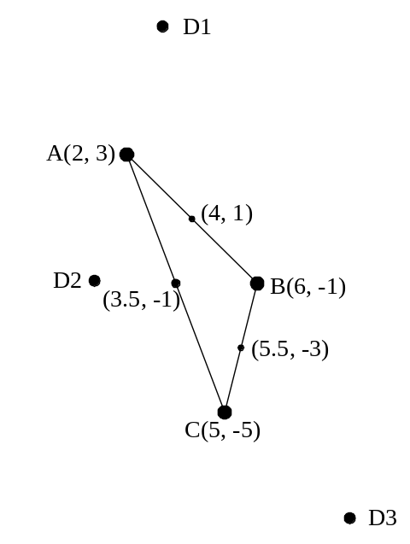
(f) D1: Midpoint of AB is (4, 1)
✓

✓

D1 (3, 7)
✓

D2: Midpoint of AC is (3.5, -1)
✓

D2 (1, -1)
✓

D3: Midpoint of BC is (5.5, -3)
✓

D3 (9, -9)

(21)
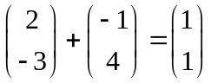13. (a) (i)
✓

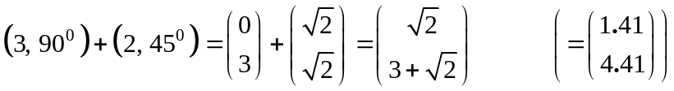
(ii)
✓

✓
✓

✓

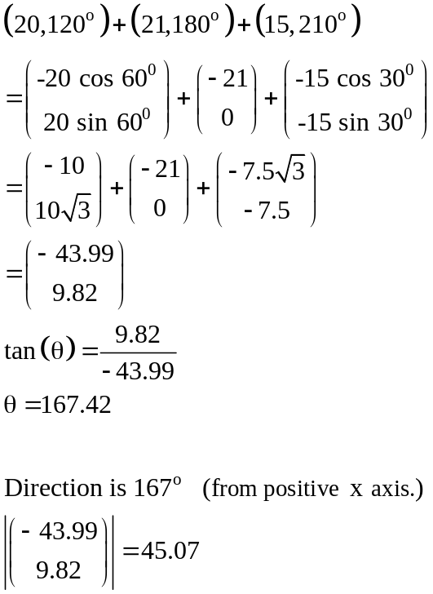
(b)
✓✓✓ -1/error

✓

✓

The resulting force is 45.07 N in
the direction 167º (N77ºW). (11)

14. (a) 3
✓
(b) (2 × 3 × 2) × (1 × 2 × 1) = 24
✓ ✓ ✓
(c) 1 × 2 × 2 = 4 ✓
(5)

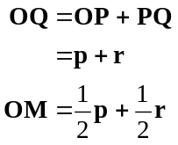15. (a) (i)
✓
✓
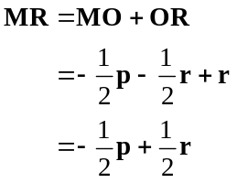 (ii)
✓
✓
✓

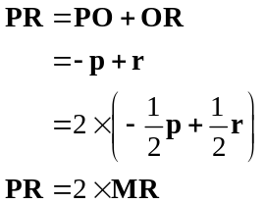 (iii)
✓

✓
R is a common point, so P, M and R are collinear.
✓
Therefore the diagonals of a parallelogram bisect each other.

(b) distance, speed
✓

Vectors need magnitude and direction.
Neither distance nor speed have direction. (10)
✓

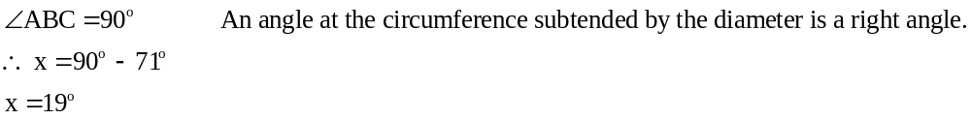16. (a)
✓

✓
-1 if theorem not quoted
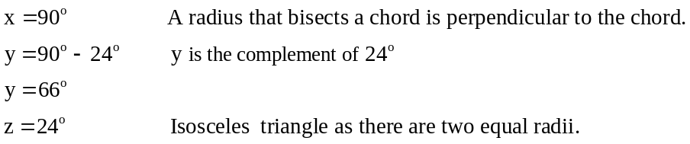
✓
(b)
✓
✓

-1 if theorem not quoted
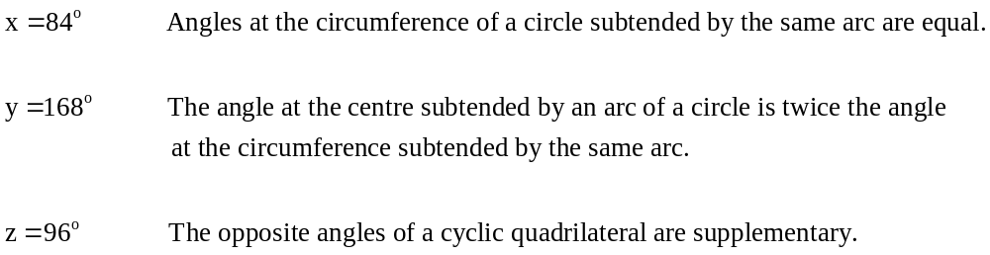 (c)
✓

✓

✓✓ -1 per theorem not quoted

✓

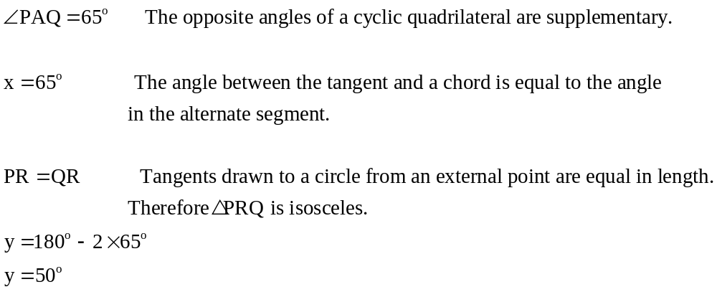 (d)
✓

✓

✓
✓✓ -1 per theorem not quoted

(15)

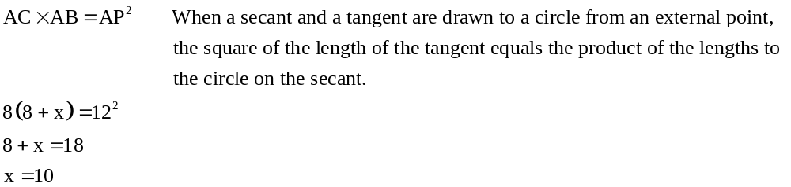17. (a)
✓

✓

✓

(b) Prove that
“When two chords of a circle intersect, the product of the lengths of the intervals on one chord equals the product of the lengths of the intervals on the other chord.”
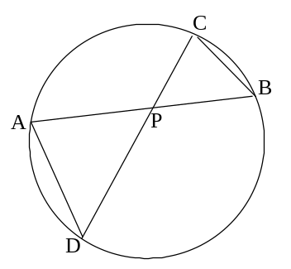 i.e. prove 

✓

Join AD, BC
In triangles APD, CPB
✓

(i) ∠APD = ∠CPB Vertically opposite angles
✓

(ii) ∠DAP = ∠BCP Angles on the same arc are equal
Therefore the triangles APD, CPB are similar.
Angle, angle.
Therefore ∠ADP = ∠CBP -2 if reasons not given
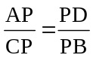 Corresponding sides are proportional.
✓

✓

✓


Therefore
“When two chords of a circle intersect, the product of the lengths of the intervals on one chord equals the product of the lengths of the intervals on the other chord.” (9)
END OF SECTION TWO

